IMAGEJ USER GUIDE

ImageJ is a public domain Java image processing and analysis program. It can read many image formats including TIFF, GIF, JPEG, BMP. ImageJ can display multiple spatially or temporally related images in a single window. These image sets are called stacks. The images that make up a stack are called slices.

Fiji (Fiji Is Just ImageJ) is a distribution of ImageJ together with Java, Java 3D and several plugins, including the LOCI plugin required to open files generated with different microscopes. ( http://wiki.imagej.net/Fiji )

- Installation and maintenance of ImageJ/ Fiji

ImageJ can be downloaded from http://imagej.nih.gov/ij/download.html

Details on how to install ImageJ are available at: http://imagej.nih.gov/ij/docs/install/

Fiji installation is described at http://fiji.sc/wiki/index.php/Downloads

The downloaded package may not contain the latest bug fixes so it is recommended to upgrade ImageJ right after a first installation. Updating IJ consists only of running Help -> Update ImageJ..., which will install the latest ij.jar in the ImageJ folder (on Linux and Windows) or inside the ImageJ.app (on Mac OSX).

- Installation of plugins

The real strength of ImageJ is the vast repertoire of Plugins that extend ImageJ’s functionality beyond its basic core. The plugins are available through the Image J web site: http://imagej.nih.gov/ij/plugins/index.html.

To install a plugin, you have to download it, copy it in the ImageJ/plugins/ folder, and restart Image J. All the plugins present in this folder are listed at the bottom of the Plugins menu.

- Open files from the microscope

- Plugins -> Bio-formats -> Bio-Formats importer ; then select the file to open
- The window : Bio-Formats import option open, select « View stack with : Hyperstack » and the default parameters
- In a new window, you can now select the image(s) you want to open
- the selected images will open
- to change the channel, move the « c slider »
- to see the different z slices, move the « z slider »

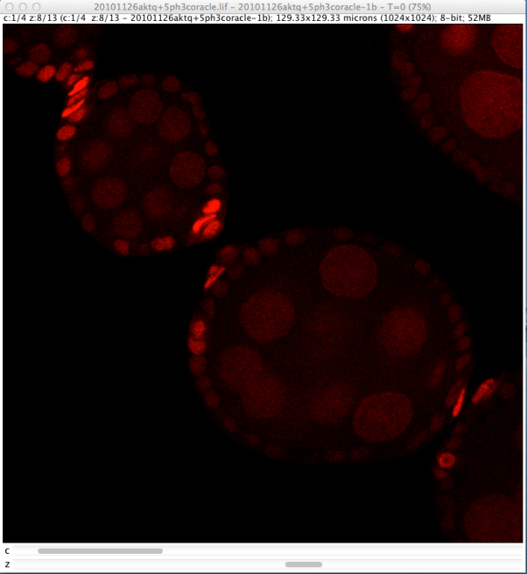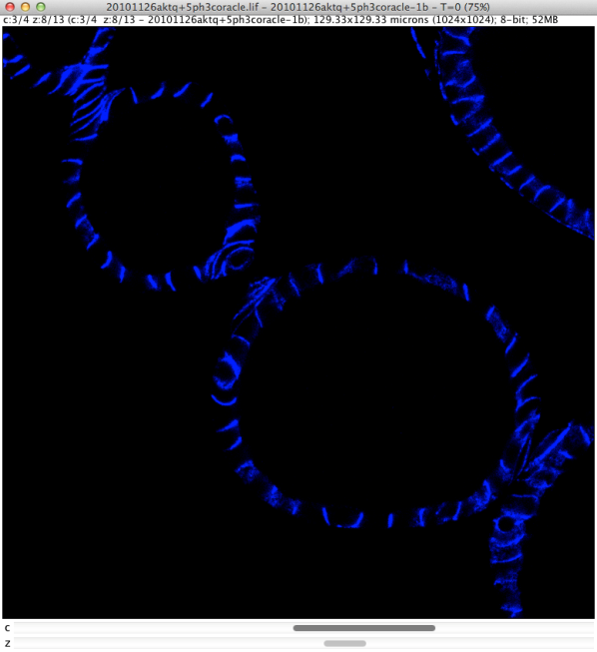
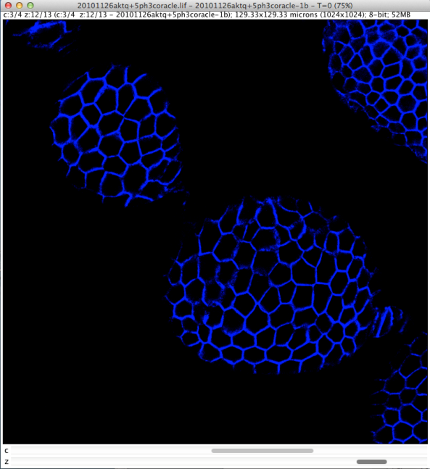

- Duplicate an image / a stack

- Since the “undo” function does not work for stacks, it is recommended to duplicate your image before any operation:
Image -> Duplicate…

- A new window will open where you can change the name, and choose which channels, slices and frames to duplicate.

- Convert image to binary image (threshold)

- To segment an image based on a threshold, you can use the function: Image -> Adjust -> Threshold…

- A new window will open, allowing you to manually define the thresholding values or choose an algorithm to automatically do the job.

- Clicking “Apply” will transform your image into a binary image (black and white) with values equal to 0 and 255.

- Change the colors and make an overlay

- Image -> color -> channels tool
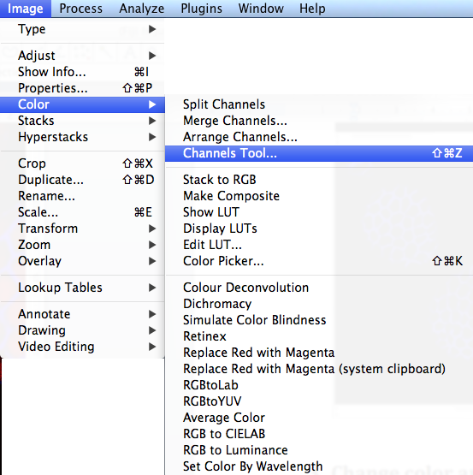

- the « channels » window opens

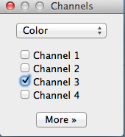

- then click on « More » to select the color you want to attribute to the selected channel

- to make an overlay select « composite »
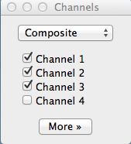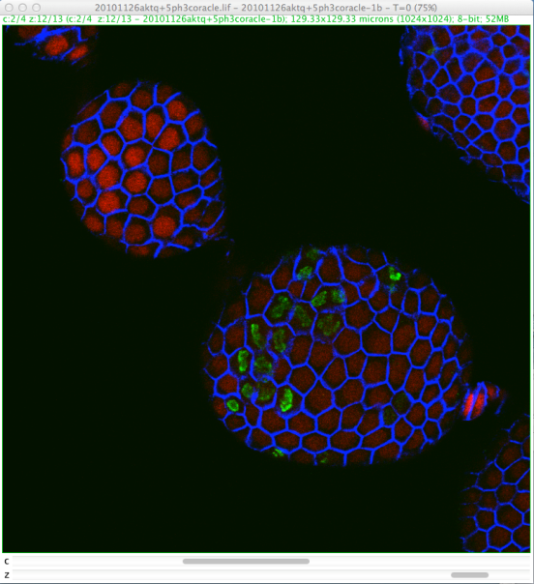
- you can select or deselect a channel to make it visible or hide it

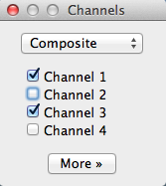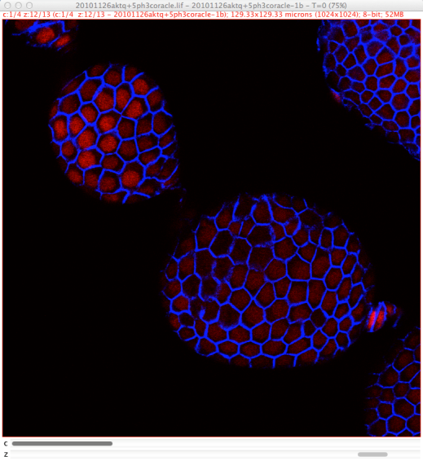

- Convert to RGB (required before saving in tiff or jpeg to obtain a file with the overlay)

- First select the channels , then in the « channels » window, click on More >> convert to RGB

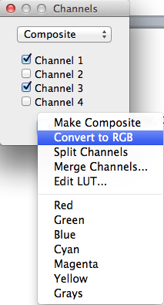
- If you have several z slices, the following window appears :

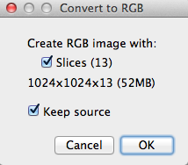

a. if “slices” is selected: you get a file with all the slices converted in RGB

b. if “slices" is not selected: you obtain a file with only the « current » slice converted in RGB

- Make a projection

- Image -> stack -> z project:

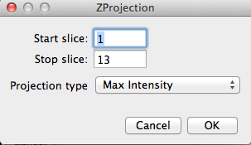

- Select the first and last slices you want to include in your projection and select the type of projection

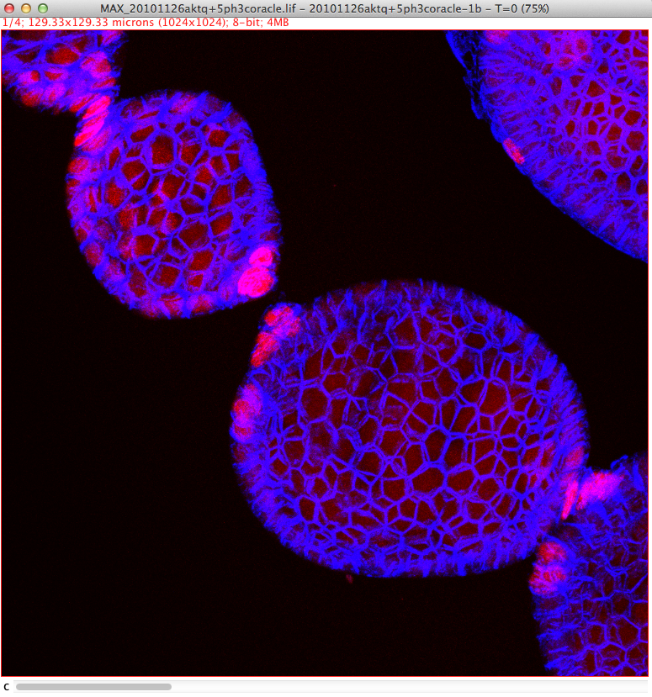

- Rotation

- Image -> transform -> rotate

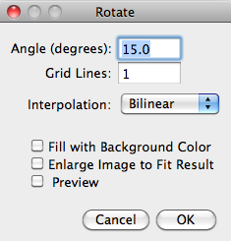

- then enter the angle of rotation

- Crop an image

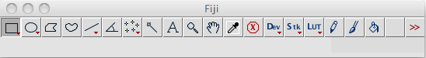

- Select the rectangle tools in the toolbar
- Design a rectangle around your region of interest
- Image -> crop

- Adjust brightness/contrast, levels…

- Image -> adjust ->brightness/contrast or window level…

- Insert a scale bar

- Analyze -> Tools -> Scale Bar

- Save in different formats

- File -> Save as (select your favorite format)

- Record a macro

- Open an image

- Plugins -> Macros -> Record…; a new window will appear

- Proceed with the operations you want to record: for each one of them, a new line will be displayed in the recorder.

- Once you are done, you can click “create”: this will open the script editor, which will allow you to edit and save your macro.

- However, if your process involves hard-coded values which need to be changed for each image (e.g. the image name), you will have to modify the generated code yourself by replacing those values with variables.

